 

## A Minor Project Report

## on

**SMOKE DETECTOR**

## Submitted by

**MOHARAJAMOORTHY K (927622BEE070) SARAVANAKARTHICK B (927622BEE102) SOWMIYA P G (927622BEE111)**



**DEPARTMENT OF ELECTRICAL AND ELECTRONICS ENGINEERING M.KUMARASAMY COLLEGE OF ENGINEERING**

(An Autonomous Institution Affiliated to Anna University, Chennai) THALAVAPALAYAM, KARUR-639113.

## MAY 2024

**M.KUMARASAMY COLLEGE OF ENGINEERING**

(Autonomous Institution, Affiliated to Anna University, Chennai)

# BONAFIDE CERTIFICATE

Certified that this Report titled **“SMOKE DETECTOR”** is the bonafide work of

## MOHARAJAMOORTHY. K (927622BEE070) , SARAVANAKARTHICK. B

**(927622BEE102)**, **SOWMIYA. P.G(927622BEE111)** who carried out the work during the academic year (2023-2024) under my supervision. Certified further that to the best of my knowledge the work reported herein does not form part of any other project report.

**SIGNATURE SIGNATURE**

**SUPERVISOR HEAD OF THE DEPARTMENT**

Mr.G.Subramaniam M.E., Dr.J.Uma M.E., Ph.D.,

Assistant Professor Professor & Head

Department of Electrical and Department of Electrical and

Electronics Engineering Electronics Engineering

M. Kumarasamy College M. Kumarasamy College of

of Engineering, Karur Engineering, Karur

Submitted for Minor Project II (18EEP202L) viva-voce Examination held at M.Kumarasamy College of Engineering,Karur-639113 on ………………..

## DECLARATION

We affirm that the Minor reject report titled **“SMOKE DETECTOR”** being submitted in partial fulfillment for the award of **Bachelor of Engineering in Electrical and Electronics Engineering** is the original work carried out by us.

|  |  |  |
| --- | --- | --- |
| **REG.NO** | **STUDENT NAME** | **SIGNATURE** |
| **927622BEE070** | **MOHARAJAMOORTHY K** | **-----------------------** |
| **927622BEE102**  **927622BEE111** | **SARAVANAKARTHICK B**  **SOWMIYA P G** | **----------------------**  **-----------------------** |

#### VISION AND MISSION OF THE INSTITUTION

**VISION**

* To emerge as a leader among the top institutions in the field of technical education

#### MISSION

* Produce smart technocrats with empirical knowledge who can surmount the global Challenges.
* Create a diverse, fully-engaged, learner - centric campus environment to provide Quality education to the students.
* Maintain mutually beneficial partnerships with our alumni, industry, and Professional associations.

#### DEPARTMENT OF ELECTRICAL AND ELECTRONICS ENGINEERING VISION

To produce smart and dynamic professionals with profound theoretical and practical knowledge comparable with the best in the field.

#### MISSION

* Produce hi-tech professionals in the field of Electrical and Electronics Engineering by inculcating core knowledge.
* Produce highly competent professionals with thrust on research.
* Provide personalized training to the students for enriching their skills.

#### PROGRAMME EDUCATIONAL OBJECTIVES(PEOs)

* **PEO1:** Graduates will have flourishing career in the core areas of Electrical Engineering and also allied disciplines.
* **PEO2:** Graduates will pursue higher studies and succeed in academic/research careers
* **PEO3:** Graduates will be a successful entrepreneur in creating jobs related to Electrical and Electronics Engineering /allied disciplines.
* **PEO4:** Graduates will practice ethics and have habit of continuous learning for their success in the chosen career.

**PROGRAMME OUTCOMES(POs)**

After the successful completion of the B.E. Electrical and Electronics Engineering degree program, the students will be able to:

**PO1: Engineering Knowledge:** Apply the knowledge of mathematics, science, engineering fundamentals, and an engineering specialization to the solution of complex engineering problems.

**PO2: Problem Analysis:** Identify, formulate, review research literature, and analyze complex engineering problems reaching substantiated conclusions using first principles of mathematics, natural sciences, and engineering sciences.

**PO3: Design/Development of solutions:**

Design solutions for Complex engineering problems and design system components or processes that meet the specified needs with appropriate consideration for the public health and safety,and the cultural, societal and environmental considerations.

**PO4: Conduct Investigations of complex problems:** Use research-based knowledge and research methods including design of experiments, analysis and interpretation of data, and synthesis of the information to provide valid conclusions.

**PO5: Modern Tool Usage:** Create, select, and apply appropriate techniques, resources, and modern engineering and IT tools including prediction and modeling to complex engineering activities with an understanding of the limitations.

**PO6:The Engineer and Society:** Apply reasoning in formed by the contextual knowledge to assess societal, health, safety, legal and cultural issues and the consequent responsibilities relevant to the professional engineering practice.

**PO7:Environment and Sustainability:** Understand the impact of the professional engineering solutions in societal and environmental contexts, and demonstrate the knowledge of, and need for sustainable development.

**PO8: Ethics:** Apply ethical principles and commit to professional ethics and responsibilities and norms of the engineering practice.

**PO9: Individual and Team work:** Function effectively as an individual, and as a member or leader in diverse teams, and in multi-disciplinary settings.

**PO10: Communication:** Communicate effectively on complex engineering activities with the engineering community and with society at large, such as, being able to comprehend and write effective reports and design documentation, make effective presentations, and give and receive clear instructions.

**PO11: Project Management and Finance:** Demonstrate knowledge and understanding of the engineering and management principles and apply these to one’s own work, as a member and leader in a team, to manage projects and in multi-disciplinary environments.

**PO12: Life-long learning:** Recognize the need for, and have the preparation and ability to engage in independent and life-long learning in the broadest context of technological change.

#### PROGRAM SPECIFIC OUTCOMES(PSOs)

The following are the Program Specific Outcomes of Engineering Students:

* **PSO1:** Apply the basic concepts of mathematics and science to analyse and design circuits, controls, Electrical machines and drives to solve complex problems.
* **PSO2:** Apply relevant models, resources and emerging tools and techniques to provide solutions to power and energy related issues & challenges.
* **PSO3:** Design, Develop and implement methods and concepts to facilitate solutions for electrical and electronics engineering related real-world problems.

|  |  |
| --- | --- |
| **Abstract (Key Words)** | **Mapping of POs and PSOs** |
| Sensor technology, Early warning, Safety devices, Emergency response, Detection technology, Risk prevention | PO1, PO2, PO3, PO4, PO5, PO6, PO7, PO8, PO9, PO10, PO11, PO12, PSO1, PSO2, PSO3. |

## [ACKNOWLEDGEMENT](https://www.google.com/search?rlz=1C1CHBD_enIN820IN820&q=ACKNOWLEDGEMENT&spell=1&sa=X&ved=0ahUKEwj99az1_ZXhAhVN63MBHRVODE4QkeECCCkoAA&cshid=1553265789884876)

Our sincere thanks to **Thiru.M.Kumarasamy Founder, and Dr.K.Ramakrishnan B.E, Chairman** of **M.Kumarasamy College of Engineering** for providing extra ordinary infrastructure, which helped us to complete the Minor project in time.

It is a great privilege for us to express our gratitude to our esteemed **Principal Dr.B.S. Murugan M.Tech., Ph.D.,** for providing us right ambiance for carrying out the project work.

We would like to thank our **Head of the Department Dr.J.Uma M.E., Ph.D., Department of Electrical and Electronics Engineering,** for her unwavering moral support throughout the evolution of the project.

We would like to express my deep gratitude to our Minor Project Guide **Mr.G.Subramaniam M.E., Assistant Professor, Department of Electrical and Electronics Engineering,** for his constant encouragement, kind co-operation, valuable suggestions and support rendered in making our project a success.

We offer our whole hearted thanks to our Minor project coordinator **Dr.B.Rajesh kumar M.E.,Ph.D., Assistant Professor, Department of Electrical and Electronics Engineering,** for his constant encouragement, kind co-operation and valuable suggestions for making our project a success.

We are glad to thank all the **Faculty Members** of **Department of Electrical and Electronics Engineering** for extending a warm helping hand and valuable suggestions throughout the project.

Words are boundless to thank **Our Parents and Friends** for their constant encouragement to complete this Minor project successfully.

# TABLE OF CONTENTS

|  |  |  |
| --- | --- | --- |
| **CHAPTER**  **NO** | **TITLE** | **PAGE NO** |
|  | **ABSTRACT** | ix |
| **1** | **SURVEY FORM ANALYSIS** | 1 |
|  | 1.1 Name and Address of the Community | 2 |
|  | 1.2 Problem identification |  |
| **2** | **LITERATURE REVIEW** | 3 |
| **3** | **PROPOSED METHODOLOGY** |  |
|  | 3.1 Block Diagram | 5 |
|  | 3.2 Description | 6 |
|  | 3.3 Cost Estimation | 7 |
| **4** | **FUTURE SCOPE AND ITS IMPLEMENTATION**  **PLAN**  **IMPLEMENTATION SURVEY FORM** | 8  9 |
|  | **REFERENCES** | 10 |

## ABSTRACT

A fire alarm system has a number of devices working together to detect and warn people through visual and audio appliances when smoke, fire, carbon monoxide or other emergencies are present. These A alarms may be activated automatically from smoke detectors, and heat detectors or may also be activated via manual fire alarm activation devices such as manual call points or pull stations. Alarms can be either motorized bells or wall mountable sounders or horns. The primary thought in the present field advances are computerizations, power utilization, and expense adequacy. Automation is implied for the decrease risk of human neglection. Two sensors viz. The Temperature sensor and Air quality sensor which are utilized as a part of the Fire Detection System to recognize a fire. The temperature sensor records the temperature of the room. The Air quality sensor detects if there is any gas present in the room. Here we have utilized an Arduino Uno to control all the command from both the sensors and execute them legitimately. Fundamentally it acts as the mind of the entire framework. An Microcontroller based house fire alarm system using a GSM Module is described in this paper. The project's primary goal is to keep residents and their belongings safe from fires, which are a common hazard in residential areas. It uses an Arduino Uno board and an ATmega328 microcontroller. The ATmega328 is the primary controller for the temperature-triggered fire alarm in the average home. The fire's heat is detected by an LM35 temperature sensor. The GSM module will use SMS to send an alarm to the user's mobile phone. A warning message will appear on the LCD display and an SMS alert will be sent to the user's phone when the temperature rises above 400C. Documentation and discussion of the test's outcomes are required. This device can assist users enhance their safety standards by providing an early response in the event of a potential accident. Finally, users will be able to protect themselves.

ix

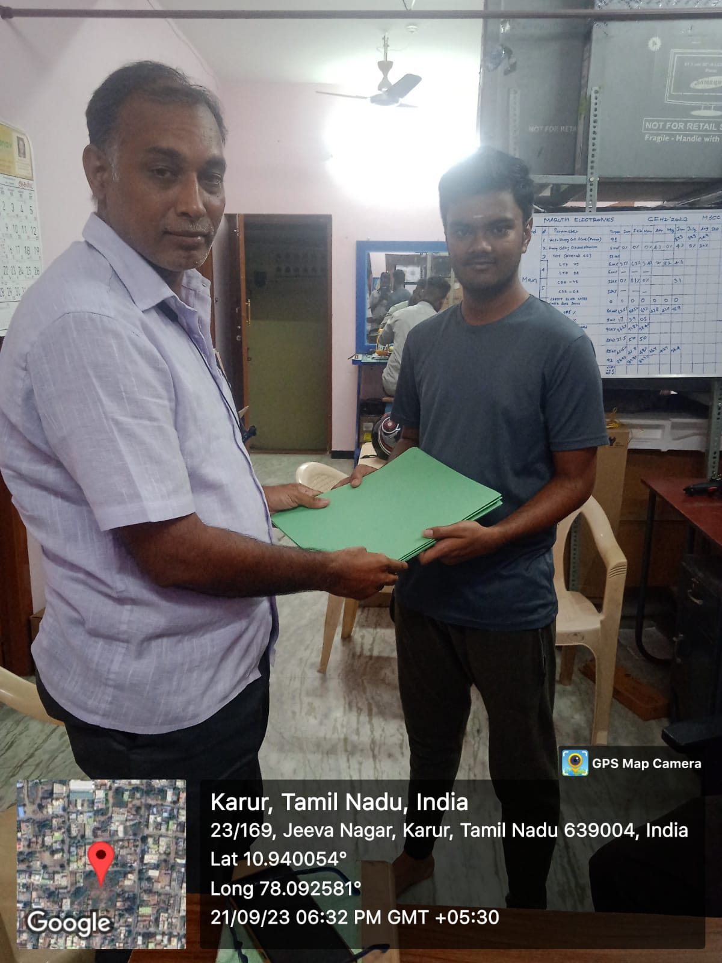 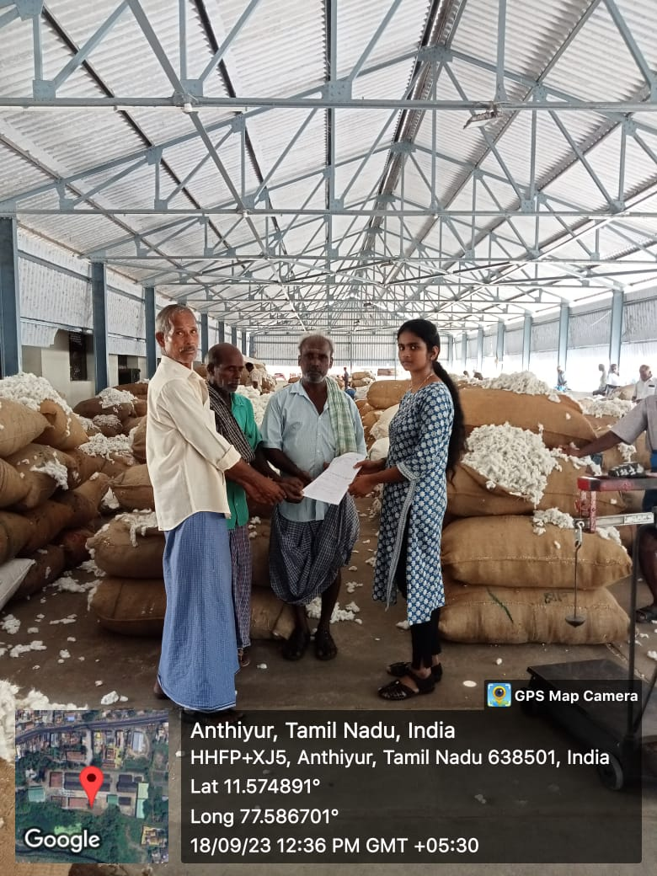

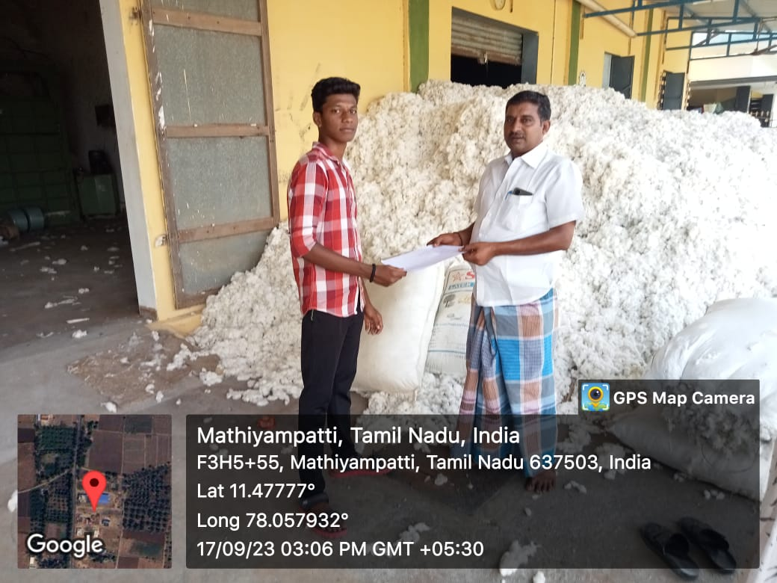

**SURVEY FORM (SAMPLE)**

#### CHAPTER 1 SURVEY FORM ANALYSIS

* 1. **NAME AND ADDRESS OF THE COMMUNITY:**

V. Mohan , Madhiyampatty , Namakkal.

T. Somasundharam , Akkaraipatti, Namakkal.

### M. Murugan, Thavittupalayam , Anthiyur .

S. Raj Kumar, Anthiyur.

### M. Jaya Kumar, Jeeva Nagar ,Karur .

* 1. **PROBLEM IDENTIFICATION:**

### By taking survey from the following localities. We came to know that the more fire incident happen in the working place like cotton mill. The employees in the service centre had attempted to solve the issues. They are experiencing the major problem like damage the thinks and health issue are happen due to the fire .

Paper 1:

TITLE: FIRE ALARM

**CHAPTER 2 LITERATURE REVIEW**

### Inference: Fire Alarm Circuit is a simple circuit that detects the fire and activates the Siren Sound or Buzzer. Fire Alarm Circuits are very important devices to detect fire at the right time and prevent any damage to people or property. Fire Alarm Circuits and Smoke Sensors are a part of the security systems which help in detecting or preventing damage.

Paper 2:

TITLE: LPG GAS SENSOR DETECTOR

### Inference: An LPG gas sensor detector is use to detect the presence of liquid petroleum gas leakage that may be source of risk and help to avoid information sent to fire station being delayed if any accident happened. It will detect the presence of gasses using MQ2 sensor, if the sensor detect the level of gasses is exceeding the normal level it will send an information through the phone apps through Internet of Thing (IOT).

Paper 3:

TITLE: HEAT DETECTOR

### Inference: A heat detector is a fire alarm device designed to respond when the convected thermal energy of a fire increases the temperature of a heat sensitive element. The thermal mass and conductivity of the element regulate the rate flow of heat into the element. All heat detectors have this thermal lag. Heat detectors have two main classifications of operation, "rate-of-rise" and "fixed temperature". The heat detector is used to help in the reduction of property damage.

Paper 4:

TITLE: WIRELESS COMMUNICATION IN SMOKE DETECTION SYSTEM

Inference:

### Research in proposed an intelligent smoke detector device the machine used the Random Forest Algorithm to detect smoke, ZigBee Transmission Technology to create a wireless network, E-charts for data analysis and a smoke detector module to capture environmental data.

Paper 5:

TITLE: ADVANCEMENTS IN FIRE DETECTION ALGORITHMS

Inference:

### A literature search process was conducted on the SCOPUS database using terms and Boolean expressions related to fire detection techniques and machine learning areas. A number of 2332 documents were returned upon the bibliometric analysis. Fourteen datasets used in the training of deep learning models were examined, discussing critically the quality parameters, such as the dataset volume, class imbalance, and sample diversity. A separate discussion was dedicated to identifying issues that require further research in order to provide further insights, and faster and more accurate models. The literature survey identified the main issues the current research should address: class imbalance in datasets, misclassification, and datasets currently used in model training. Recent advances in deep learning models such as transfer learning and (vision) transformers were discussed.

#### CHAPTER 3

**PROPOSED METHODOLOGY**

#### BLOCK DIAGRAM

#### 

**3.2 DESCRIPTION**

### Our project is based on the detection of smoke. By using the IR sensor we will detect the smoke and with the help of alarm we can identify the smoke in the industries. If there is any presence of smoke in the industries the sensor will find the and start to make an alert. After the alarm sound we can identify the smoke proned areas and safeguard ourselves. With the help of this system we can safeguard the labours working in the industries. In this project we use the flame sensor is a type of sensor that can detect and respond to the presence of a flame. These detectors have the ability to identify smokeless liquid and smoke that can create open fire. For example, flame detectors are widely used, as a flame detector can detect heat, smoke, and fire. Application of Smoke alarms detect fires by sensing small particles in the air using a couple of different kinds of technologies. Once they detect those particles above a certain level, they signal the alarm to sound so that you and your family can get to safety. Arduino is the main board, which is an open-source microcontroller-based kit. The Arduino system offers a set of analog and digital pins that can be interfaced with many other boards and circuits which have different functions in a design. Figure 1 shows the Arduino Uno board. A sensor which is most sensitive to a normal light is known as a flame sensor. That’s why this sensor module is used in flame alarms. This sensor detects flame otherwise wavelength within the range of 760 nm – 1100 nm from the light source. This sensor can be easily damaged to high temperature. GSM module is a device that allows electronic devices to communicate with each other over the GSM network. GSM is a standard for digital cellular communications, which means that it provides a platform for mobile devices to communicate with each other wirelessly.

#### COST ESTIMATION

|  |  |  |  |
| --- | --- | --- | --- |
| S.NO | COMPONENT DESCRIPTION | QUATITY | COST |
| 1 | ARDUINO UNO | 1 | 1,100 |
| 2 | FLAME SENSOR | 1 | 250 |
| 3 | GSM MODULE SIM 900A | 1 | 800 |
| 4 | BUZZER | 1 | 50 |
| 5 | 12v POWER SOURCE | 1 | 50 |
| 6 | JUMPER CABLES | 1 | 200 |
|  |  | TOTAL | 2450 |

**CHAPTER 4**

#### FUTURE SCOPE & ITS IMPLEMENTATION PLAN

The future scope and implementation of GSM-based fire detectors are quite promising, as they offer an efficient and reliable way to detect fires and communicate emergency situations. Some potential areas of growth and development for GSM-based fire detectors may include:

1. Enhanced Connectivity: Future advancements in GSM technology may lead to improved connectivity and network coverage, allowing for more reliable communication of fire emergencies to authorities and building occupants
2. Integration with Smart Home Systems: GSM-based fire detectors may be integrated with smart home systems to provide real-time alerts and notifications to homeowners, emergency services, and property managers.
3. Advanced Monitoring and Control: In the future, GSM-based fire detectors may incorporate advanced monitoring and control features, allowing for remote access and management of the system through mobile devices or web-based platforms.
4. Data Analytics and Predictive Maintenance: Integration with data analytics and machine learning algorithms may enable predictive maintenance and early detection of potential fire hazards, enhancing the overall safety and reliability of the system.
5. Regulatory Compliance: Advancements in GSM-based fire detection systems may align with evolving regulatory standards and building codes, ensuring that they meet the requirements for fire safety and emergency communication.

Overall, the future scope for GSM-based fire detectors appears to be focused on increasing their functionality, connectivity, and reliability, making them an integral part of modern fire protection and emergency response systems.

IMPLEMENTATION

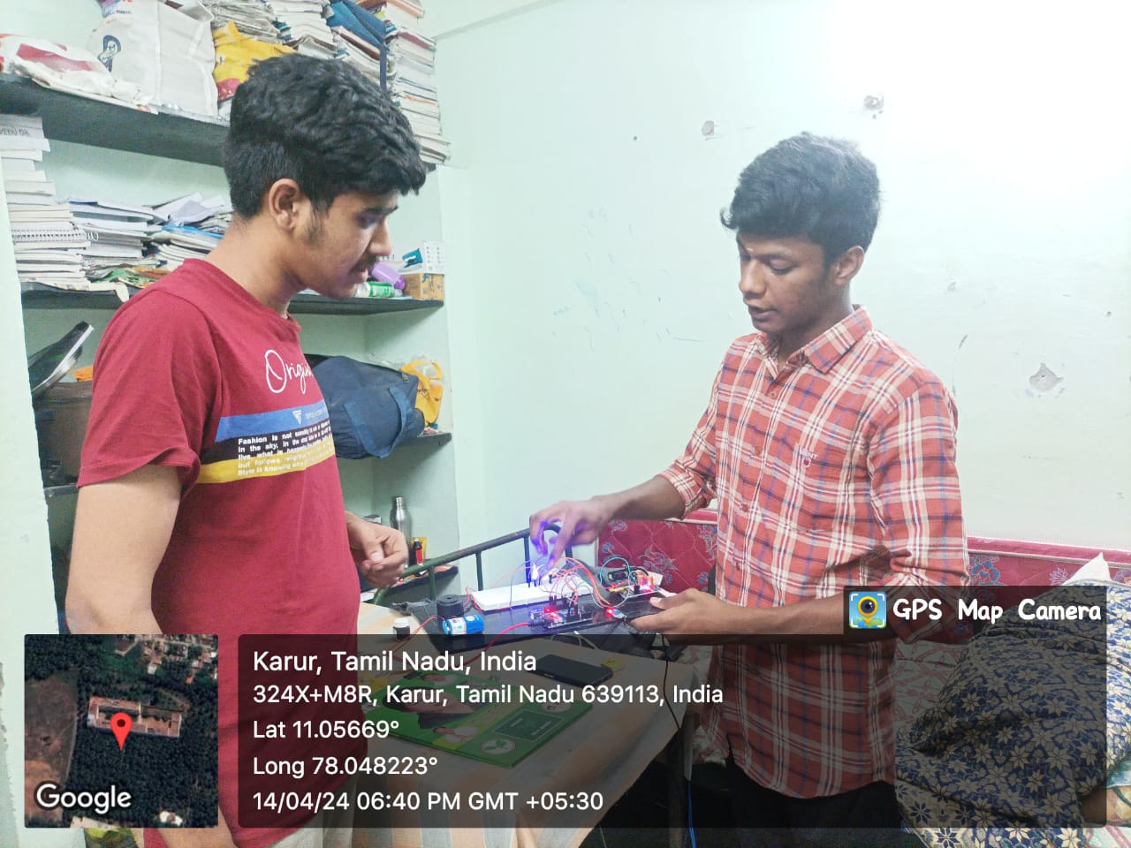

REFERENCES:

1. "Wireless Fire Detection System Using GSM Technology" by A.R. Tapkir, T.P. Sankar and S.G. Burli in International Journal of Advanced Research in Computer Science and Software Engineering
2. "Development of a GSM-based fire alarm system" by M O Gbologe, Y O Ojo and A A J Agwai in IOP Conference Series: Materials Science and Engineering.
3. "GSM Based Fire Alarm System" by H. U. Danbaze, S. G. Abubakar, M. Gani, and

L. M. Sa'ad in International Journal of Scientific & Engineering Research.

4.Refer the video link :

https://drive.google.com/file/d/1b9xmXic02KX1_aEMOW5_NMi_vdRiBLS9/view?usp=drivesdk